**Number Systems Used In Computers**

Complete the following table:

|  |  |  |  |
| --- | --- | --- | --- |
| **Number System** | **Number Base** | **Digits Used** | **Purpose** |
| Decimal | Base 10 | 0 to 9 | Used for communicating with human users |
| Binary |  |  |  |
| Octal |  |  |  |
| Hexadecimal |  |  |  |

**Decimal vs. Binary System**

Write down the definition of a **Bit** in computer terminology:

Complete the following table:

|  |  |  |
| --- | --- | --- |
|  | **Decimal System** | **Binary System** |
| Uses Digits |  |  |
| Addition Examples |  |  |
| Powers of 10 |  |  |
| Evaluate 111 |  |  |

**Powers of 2**

|  |  |  |  |  |
| --- | --- | --- | --- | --- |
| **Power  of 2** | **Decimal Value** | **Integer Range** | **Number  of Bits** | **Computer Binary** |
| 21 | 2 | 0 - 1 | 1 | 0001 |
| 22 | 4 | 0 - 3 | 2 | 0011 |
| 23 |  |  |  | 0111 |
| 24 |  |  |  | 1111 |
| 25 |  |  |  | 0001 1111 |
| 26 |  |  |  | 0011 1111 |
| 27 |  |  |  | 0111 1111 |
| 28 | 256 | 0 - 255 | 8 | 1111 1111 |
| 29 |  |  |  | 0001 1111 1111 |
| 210 |  |  |  | 0011 1111 1111 |
| 211 |  |  |  | 0111 1111 1111 |
| 212 |  |  |  | 1111 1111 1111 |
| 213 |  |  |  | 0001 1111 1111 1111 |
| 214 |  |  |  | 0011 1111 1111 1111 |
| 215 |  |  |  | 0111 1111 1111 1111 |
| 216 | 65,536 | 0 – 65,535 | 16 | 1111 1111 1111 1111 |

**Conversions**

Convert the following binary numbers to decimal:

11 binary =

101 binary =

1010 binary =

Convert the following decimal numbers to binary:

6 decimal =

13 decimal =

**Binary Addition**

Add the following binary numbers. (verify your answers using decimal)

|  |  |  |  |  |  |  |  |  |  |  |  |  |  |
| --- | --- | --- | --- | --- | --- | --- | --- | --- | --- | --- | --- | --- | --- |
| |  |  | | --- | --- | | **0101** | **(decimal 5)** | | **+ 0010** | **(decimal 2)** | |  |  | | |  |  | | --- | --- | | **0101** | **(decimal 5)** | | **+ 1010** | **(decimal 10)** | |  |  | |
| |  |  | | --- | --- | | **0011** | **(decimal 3)** | | **+ 0010** | **(decimal 2)** | |  |  | | |  |  | | --- | --- | | **0110** | **(decimal 6)** | | **+ 0011** | **(decimal 3)** | |  |  | |

**Prefixes**

* Kilo (K) means __________________ Multiply by x______________
* Mega (M) means _________________ Multiply by x______________

* Giga (G) means __________________ Multiply by x______________
* Tera (T) means __________________ Multiply by x______________

**Examples**

1. 64 Kbps (Kilo-bits per seconds) = ___________________ bps (bits per second)
2. 256 Giga-bytes = _________________________________ bytes
3. 256 Giga-bytes = _________________________________ bits

**Computer Memory Structures**

|  |  |  |  |
| --- | --- | --- | --- |
| **Structure** | **Number of Bits** | **Largest Value** | **Used For...** |
| Bit |  |  |  |
| Byte |  |  |  |
| Word |  |  |  |
| Short Integer |  |  |  |
| Double Word |  |  |  |
| Long Integer |  |  |  |
| Memory Address |  |  |  |

**Memory Organization**

Bit (Binary Digit)

* One bit can have a value of ________ or _________
* Or a Boolean logic value of ________ or _________

|  |  |  |  |  |  |  |  |  |  |  |  |  |  |  |  |  |  |  |  |
| --- | --- | --- | --- | --- | --- | --- | --- | --- | --- | --- | --- | --- | --- | --- | --- | --- | --- | --- | --- |
| |  |  |  |  | | --- | --- | --- | --- | | 0 | 0 | 0 | 0 | | |  |  |  |  | | --- | --- | --- | --- | | 0 | 0 | 0 | 0 | | |  |  |  |  | | --- | --- | --- | --- | | 0 | 0 | 0 | 0 | | |  |  |  |  | | --- | --- | --- | --- | | 0 | 0 | 0 | 0 | |

Byte (8 bits)

* One byte has a size of ________ bits
* A byte has an unsigned integer value range from 0 to _________

|  |  |  |  |  |  |  |  |  |  |  |  |  |  |  |  |  |  |  |  |
| --- | --- | --- | --- | --- | --- | --- | --- | --- | --- | --- | --- | --- | --- | --- | --- | --- | --- | --- | --- |
| |  |  |  |  | | --- | --- | --- | --- | | 0 | 0 | 0 | 0 | | |  |  |  |  | | --- | --- | --- | --- | | 0 | 0 | 0 | 0 | | |  |  |  |  | | --- | --- | --- | --- | | 0 | 0 | 0 | 0 | | |  |  |  |  | | --- | --- | --- | --- | | 0 | 0 | 0 | 0 | |

Word (2 bytes or 16 bits)

* One word has a size of ________ bits
* One word has a size of ________ bytes
* A byte has an unsigned integer value range from 0 to _________

|  |  |  |  |  |  |  |  |  |  |  |  |  |  |  |  |  |  |  |  |
| --- | --- | --- | --- | --- | --- | --- | --- | --- | --- | --- | --- | --- | --- | --- | --- | --- | --- | --- | --- |
| |  |  |  |  | | --- | --- | --- | --- | | 0 | 0 | 0 | 0 | | |  |  |  |  | | --- | --- | --- | --- | | 0 | 0 | 0 | 0 | | |  |  |  |  | | --- | --- | --- | --- | | 0 | 0 | 0 | 0 | | |  |  |  |  | | --- | --- | --- | --- | | 0 | 0 | 0 | 0 | |
|  | |  | |

Long or Double Word (4 bytes or 32 bits)

* One Long word has a size of ________ words
* A Long word has an unsigned integer value range from 0 to _________

|  |  |  |  |  |  |  |  |  |  |  |  |  |  |  |  |  |  |  |  |
| --- | --- | --- | --- | --- | --- | --- | --- | --- | --- | --- | --- | --- | --- | --- | --- | --- | --- | --- | --- |
| |  |  |  |  | | --- | --- | --- | --- | | 0 | 0 | 0 | 0 | | |  |  |  |  | | --- | --- | --- | --- | | 0 | 0 | 0 | 0 | | |  |  |  |  | | --- | --- | --- | --- | | 0 | 0 | 0 | 0 | | |  |  |  |  | | --- | --- | --- | --- | | 0 | 0 | 0 | 0 | |
|  | |  | |
| |  |  |  |  | | --- | --- | --- | --- | | 0 | 0 | 0 | 0 | | |  |  |  |  | | --- | --- | --- | --- | | 0 | 0 | 0 | 0 | | |  |  |  |  | | --- | --- | --- | --- | | 0 | 0 | 0 | 0 | | |  |  |  |  | | --- | --- | --- | --- | | 0 | 0 | 0 | 0 | |
|  | |  | |

**Questions**

1. What is the smallest memory object that can represent a character of information?
   1. Think… How many upper case letters in the alphabet (A to Z)? **26**
   2. Think… How many lower case letters in the alphabet (a to z)? **26**
   3. Think… How many number digits (0 to 9)? **10**
   4. Think… How many punctuation marks? **14**
   5. Add them all up **26+26+10+14 = 76**
2. Research the ASCII characters set. What is it and how is it related to computer memory?

* ASCII, abbreviated from American Standard Code for Information Interchange.
* It is a character encoding standard for electronic communication. ASCII codes represent text in computers, telecommunications equipment, and other devices.
* On modern machines, each of the 128 **ASCII characters** is the low seven bits of an octet or 8-bit byte; octets are packed into **memory** words so that (for example) a six-**character** string only takes up one 64-bit **memory** word. it uses eight bits to **represent** a letter or a punctuation mark. ... A binary **code** with eight digits, such as 1101 10112, can be stored in one byte of **computer memory**.

1. How are strings of characters (Google “String”) represented in computer memory?

By execution purpose and heap is used for storage purpose. ... Whenever you create a **string** object using **string** literal, that object is **stored** in the **string** constant pool and whenever you create a **string** object using new keyword, such object is **stored** in the heap **memory**

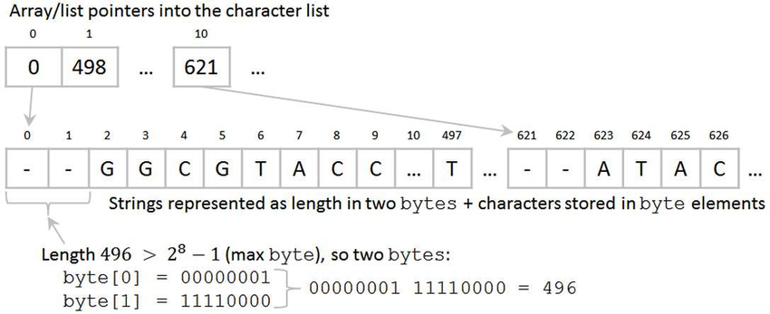

1. How are negative integers represented in computer memory? (Include a diagram)

**Integers** are commonly **stored** using a word of **memory**, which is 4 bytes or 32 bits, so **integers** from 0 up to 4,294,967,295 (232 - 1) can be **stored**. Below are the **integers** 1 to 5 **stored** as four-byte values (each row **represents** one **integer**).

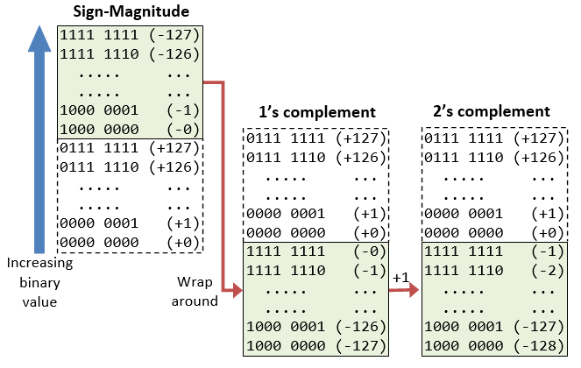

1. How are decimal numbers (Google “Floating Point”) represented in computer memory? (Include a diagram)  
    in **computers**, **floating-point numbers** are **represented** in scientific notation of fraction ( F ) and exponent ( E ) with a radix of 2, in the form of F×2^E . Both E and F can be positive as well as negative.

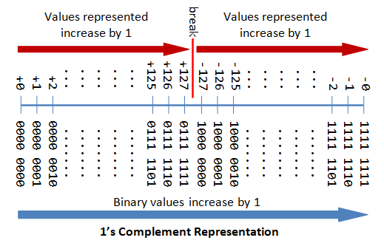

1. A Pixel is computer memory structure used to store image information. How is a Pixel represented in memory? (Include a diagram).

**pixel** is **represented** in a computer **memory** by a fixed number of bits. Typical **pixel** bit depth (amount of bits per **pixel**) is 32, 16, 8

